2.1 Data Flow Diagram & User Stories
Date | 10 July 2026
Team ID
Project Name | Book a Doctor App
Maximum Marks | 4 Marks

A Data Flow Diagram (DFD) is a traditional visual representation of the information flows within a system. A neat and clear DFD can depict the right amount of the system requirement graphically. It shows how data enters and leaves the system, what changes the information, and where data is stored.
Data Flow Diagram (Level-0)
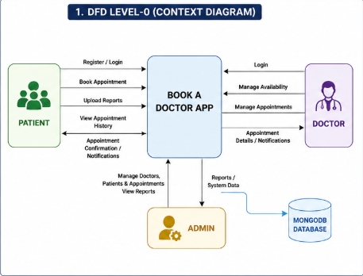
The Level-0 Data Flow Diagram (Context Diagram) provides a high-level overview of the Book a Doctor App. It illustrates the interaction between the primary external entities—Patient, Doctor, and Admin—and the application. Patients can register, log in, book appointments, upload medical reports, and view appointment history. Doctors manage their availability, view appointments, and update appointment statuses. The Admin oversees user management, doctor approvals, appointments, and system reports. All application data is securely stored and retrieved from the MongoDB database, ensuring efficient data management and seamless communication between users and the system.
Data Flow Diagram (Level-1)
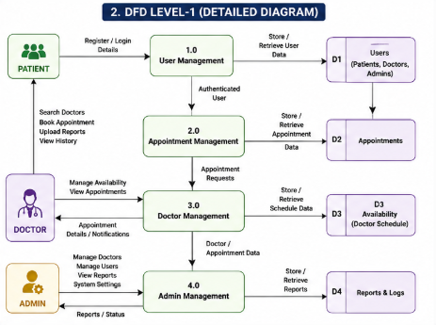
The Level-1 Data Flow Diagram provides a detailed representation of the internal processes of the Book a Doctor App. It decomposes the main system into functional modules such as User Management, Appointment Management, Doctor Management, and Admin Management. User information is processed through the User Management module, while appointment requests are handled by the Appointment Management module. Doctors manage their schedules and appointment details through the Doctor Management module, whereas administrators supervise users, doctors, and reports using the Admin Management module. Each module interacts with the corresponding database collections to store and retrieve information efficiently.
User Stories
User Type | Functional Requirement (Epic) | User Story No. | User Story / Task | Acceptance Criteria | Priority | Release
Patient | Registration | USN-1 | As a patient, I can register by providing my personal details to access the application. | Account created successfully. | High | Sprint-1
Patient | Login | USN-2 | As a patient, I can log in securely using my email and password. | Login successful. | High | Sprint-1
Patient | Book Appointment | USN-3 | As a patient, I can search doctors and book appointments. | Appointment confirmed. | High | Sprint-1
Patient | Appointment History | USN-4 | As a patient, I can view all my previous and upcoming appointments. | Appointment history displayed. | Medium | Sprint-2
Patient | Upload Medical Reports | USN-5 | As a patient, I can upload my medical documents securely. | Reports uploaded successfully. | Medium | Sprint-2
Doctor | Appointment Management | USN-6 | As a doctor, I can approve or reject appointments. | Appointment status updated. | High | Sprint-1
Doctor | Availability | USN-7 | As a doctor, I can update my availability schedule. | Schedule updated successfully. | High | Sprint-2
Admin | Doctor Management | USN-8 | As an admin, I can approve doctor registrations. | Doctor approved successfully. | High | Sprint-1
Admin | User Management | USN-9 | As an admin, I can manage users and appointments. | User details updated. | High | Sprint-2

